Room Level Temp Control for Central HVAC Systems
Students | Geoffrey Stoner Jia Qian | Spring
Students | Geoffrey Stoner Jia Qian | 2015
Advisors | Dr. Bassem Alhalabi | 2015

Objectives

Our design is a multi-room comfort system that regulates temperature of each room in the house rather than having one centralized thermostat that controls the temperature for the entire house. Using this system will help alleviate one room in the house that is cooler or warmer than others in the house and or individual rooms can be raised or lowered for comfort or economy reasons.

General Description

The system would require a thermostat unit in each room. Each thermostat unit will contain a display screen as well as temperature adjustment buttons. The thermostat would display room temperature and show set temperature. The operator would adjust the set temperature by using the up and down buttons. If there is a temperature disparity of two degrees the thermostat will request the servo unit to open an electrically operated damper would be installed in each room’s ventilation supply ducts and supply the room with ventilation. A future expansion would also communicate wirelessly to a main control unit that would replace the houses central thermostat. The control unit will communicate with each rooms thermostat and turn the HVAC unit on or off as necessary. For best efficiency there would ba a network of several of the thermostat control units that will also adjust the airflow into each room by

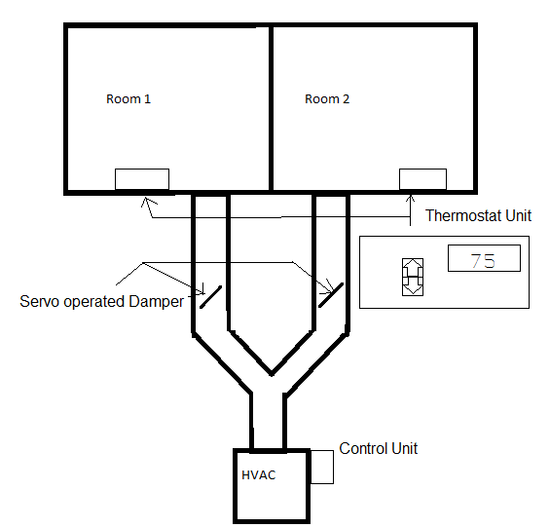

adjusting the room’s damper, supplying more
airflow to warmer rooms and less or no airflow to colder rooms when operating in AC mode.

Mockup

The mockup of our project will include a thermostat units. It will require a TI-MSP430 (1). The thermostat units will need a 2x8 LCD display (1) as well as 2 SPST momentary contact switches or touch switches (2). Various resistors and capacitors will be needed as well as noted in the circuit diagram.

